**Phase 5: Apex Programming (Developer)**

Performing the apex programming

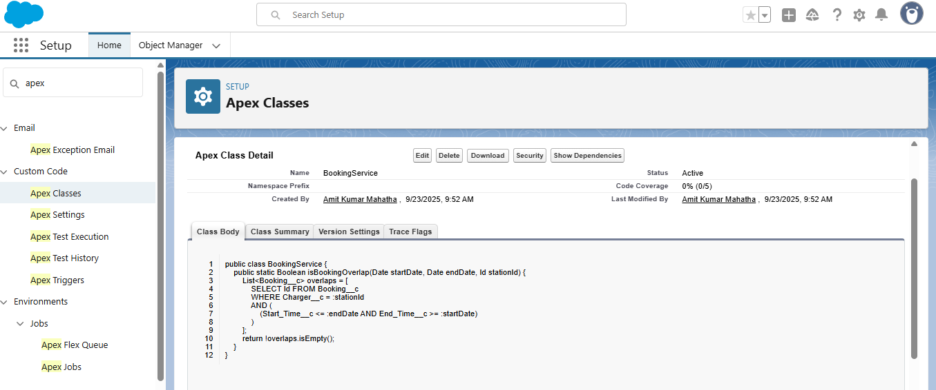

public class BookingService {

public static Boolean isBookingOverlap(Date startDate, Date endDate, Id stationId) {

List<Booking__c> overlaps = [

SELECT Id FROM Booking__c

WHERE Charger__c = :stationId

AND (

(Start_Time__c <= :endDate AND End_Time__c >= :startDate)

)

];

return !overlaps.isEmpty();

}

}

Apex Trigger:

**Navigation:**

* Go to **Setup → Apex Classes → New**.

| trigger BookingTrigger on Booking__c (before insert, before update) {  for (Booking__c b : Trigger.new) {  if (BookingService.isBookingOverlap(b.Start_Time__c, b.End_Time__c, b.Charger__c)) {  b.addError('This charging station is already booked for the selected time.');  }  }  } |
| --- |

